AWS TASK-2

Task Description:
Set up a VPC with an Internet gateway, create a public subnet with 256 IP addresses, a private subnet with 256 IP addresses, make a route table connecting the Internet gateway and the subnets, and launch a Linux EC2 instance by using the above VPC and public subnet.
O/P:
1.Create a VPC.
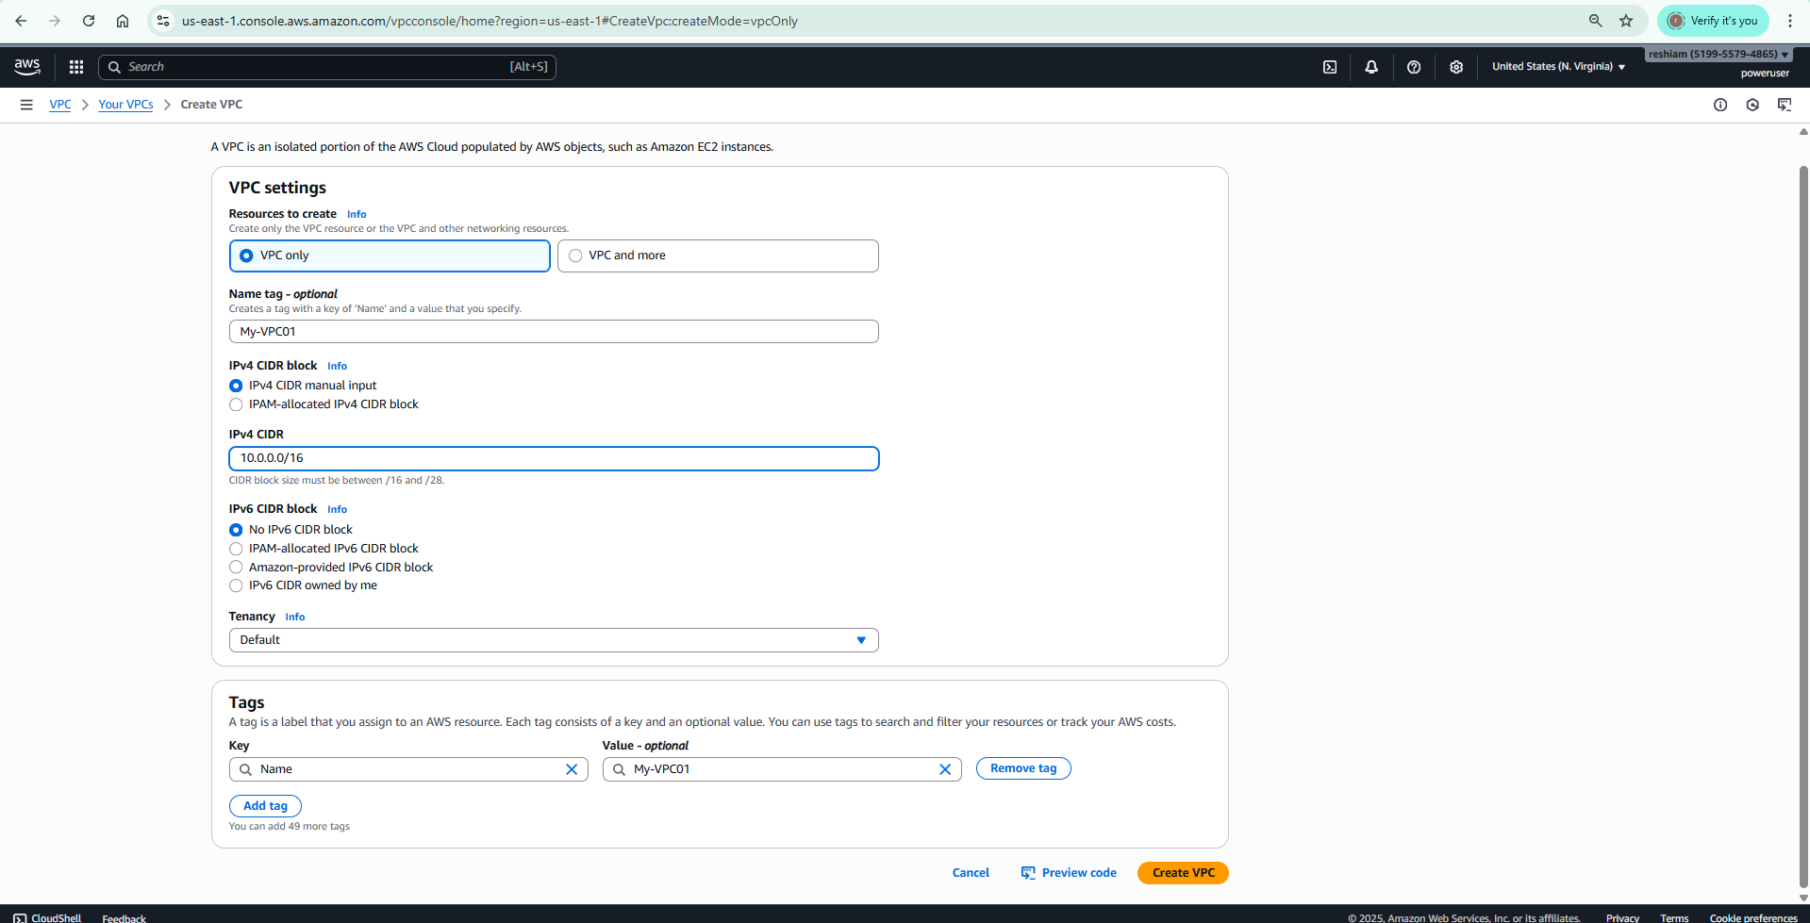
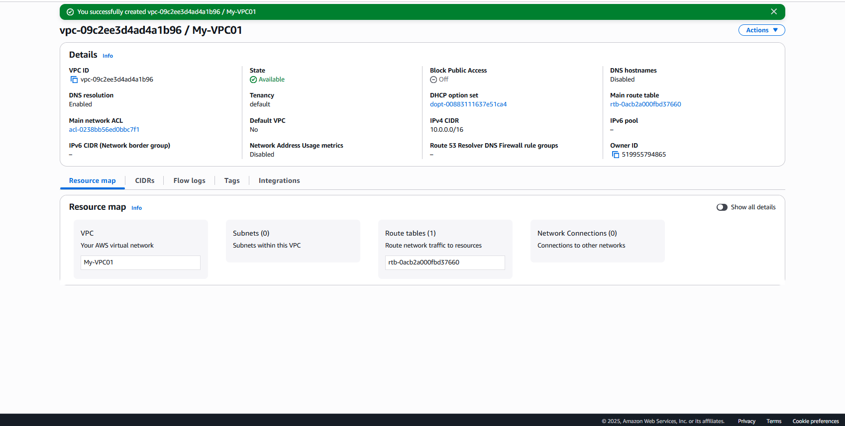
2.Create a Subnet
a. Private Subnet:
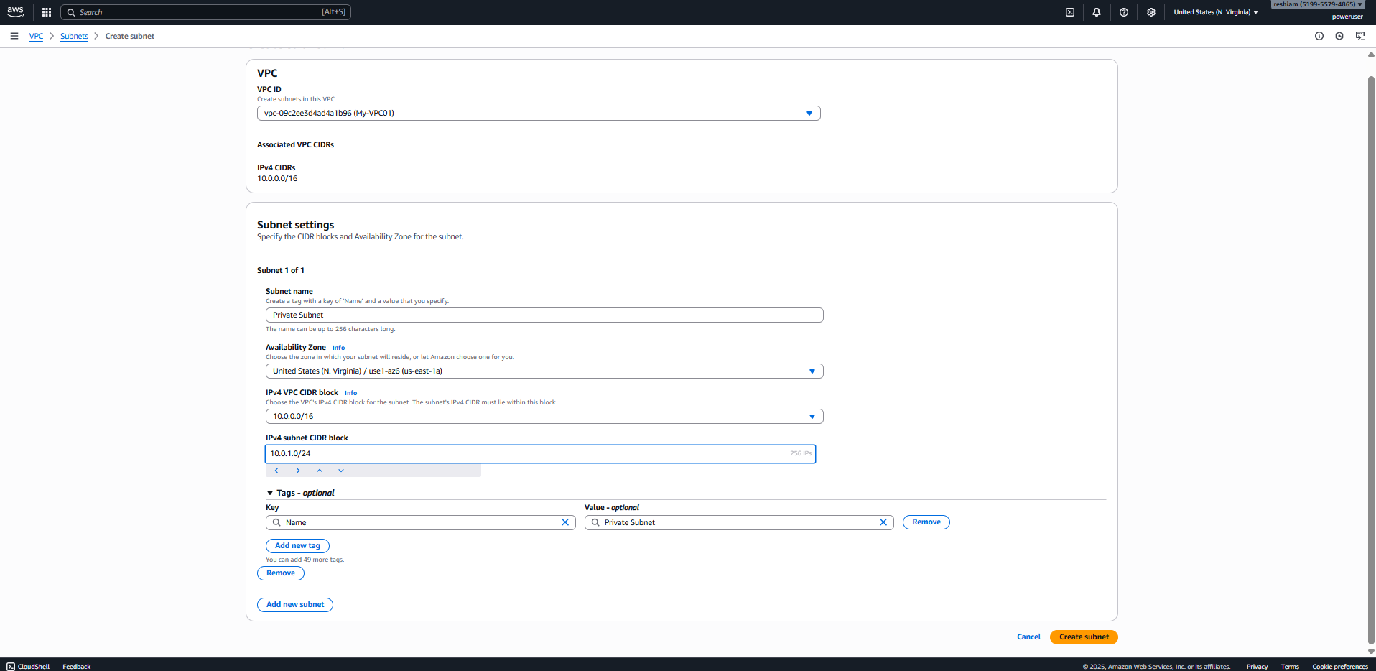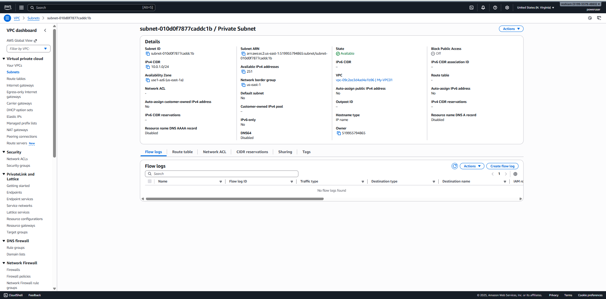
b. Public Subnet: 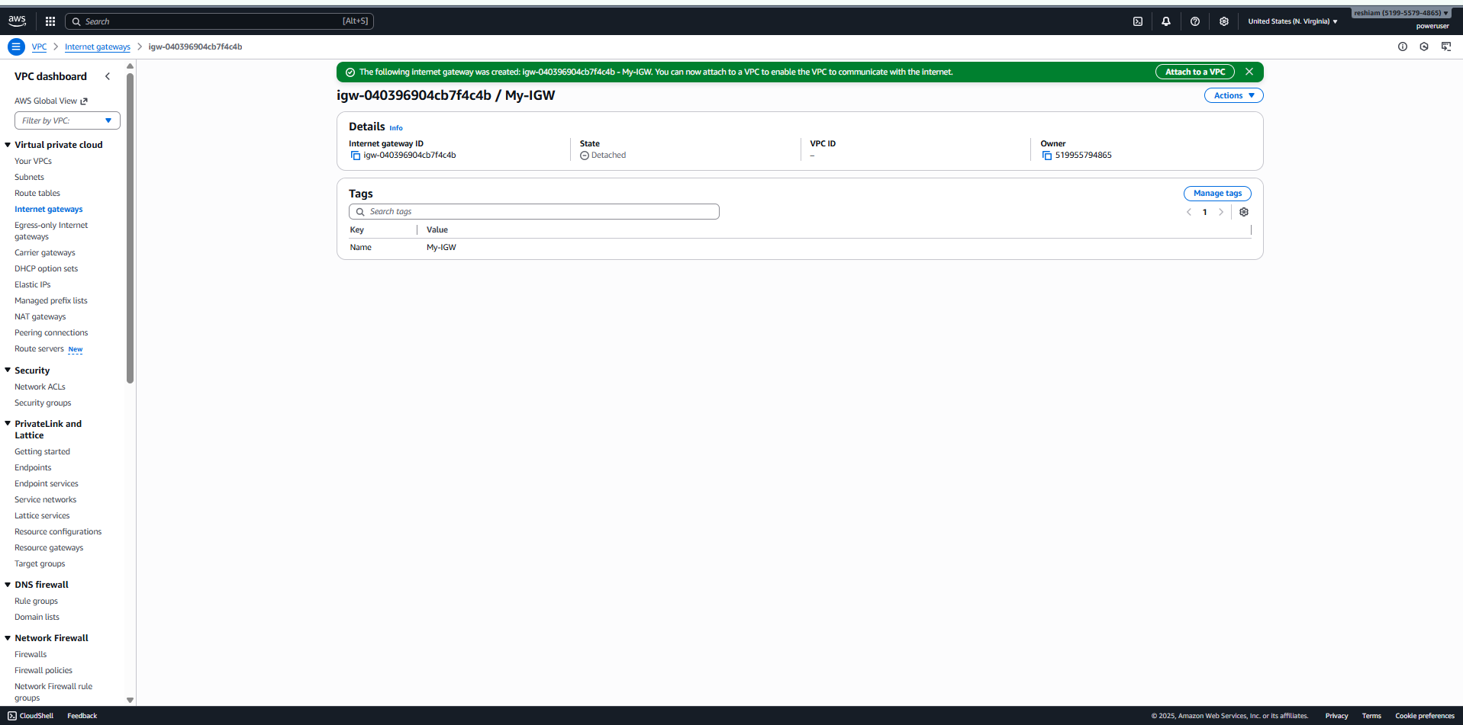
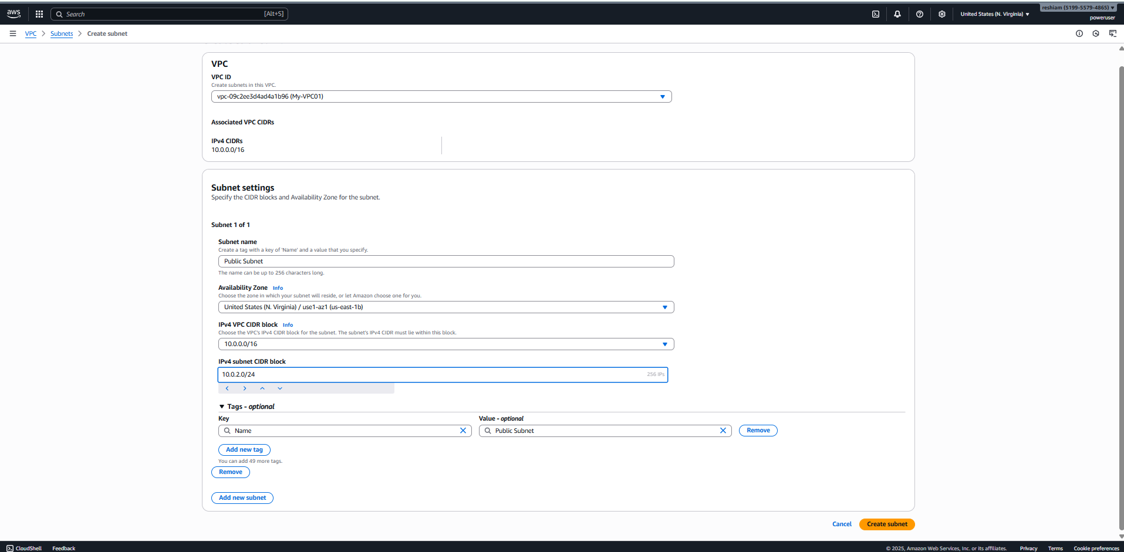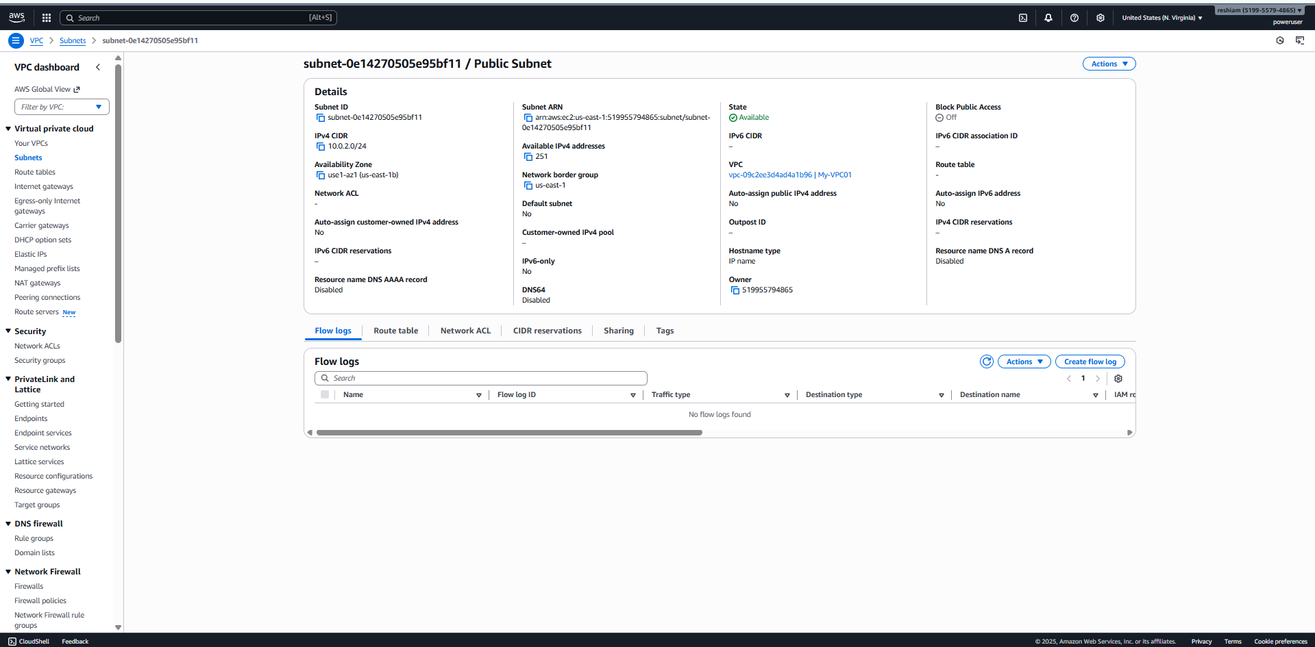
3.Create a Route Table
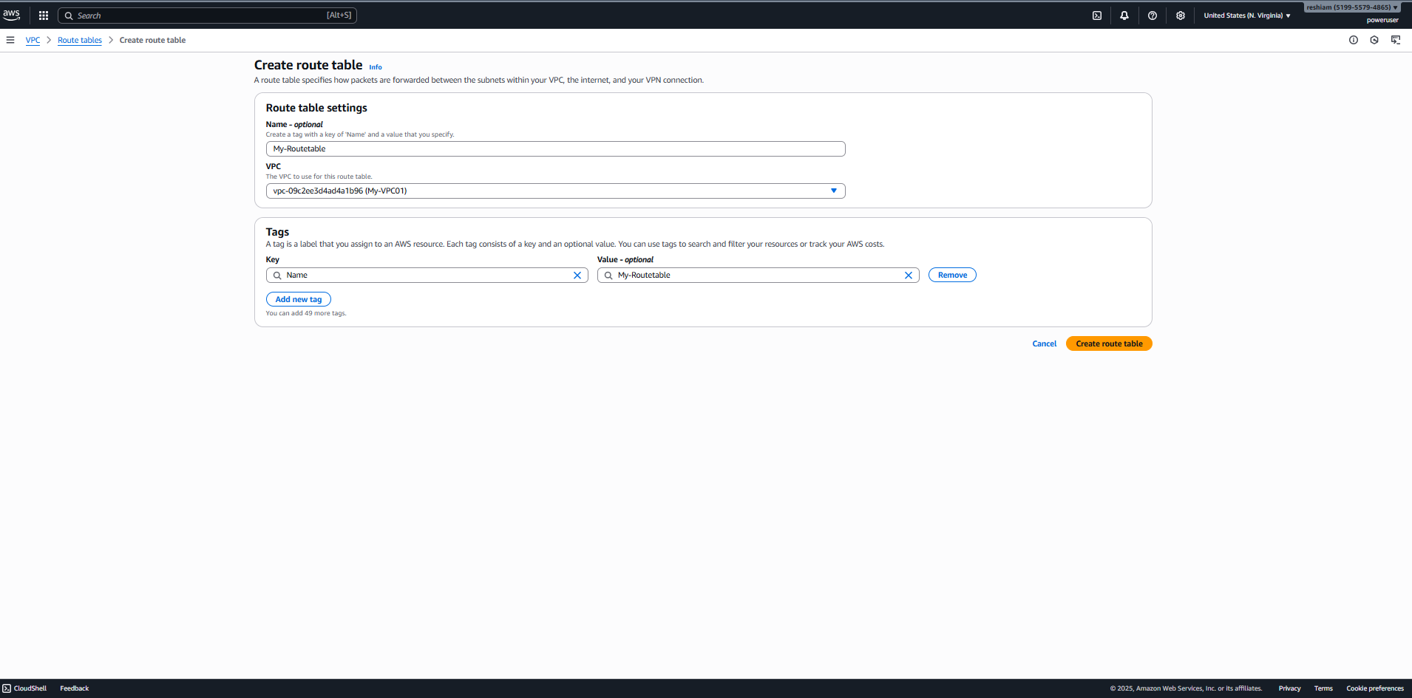
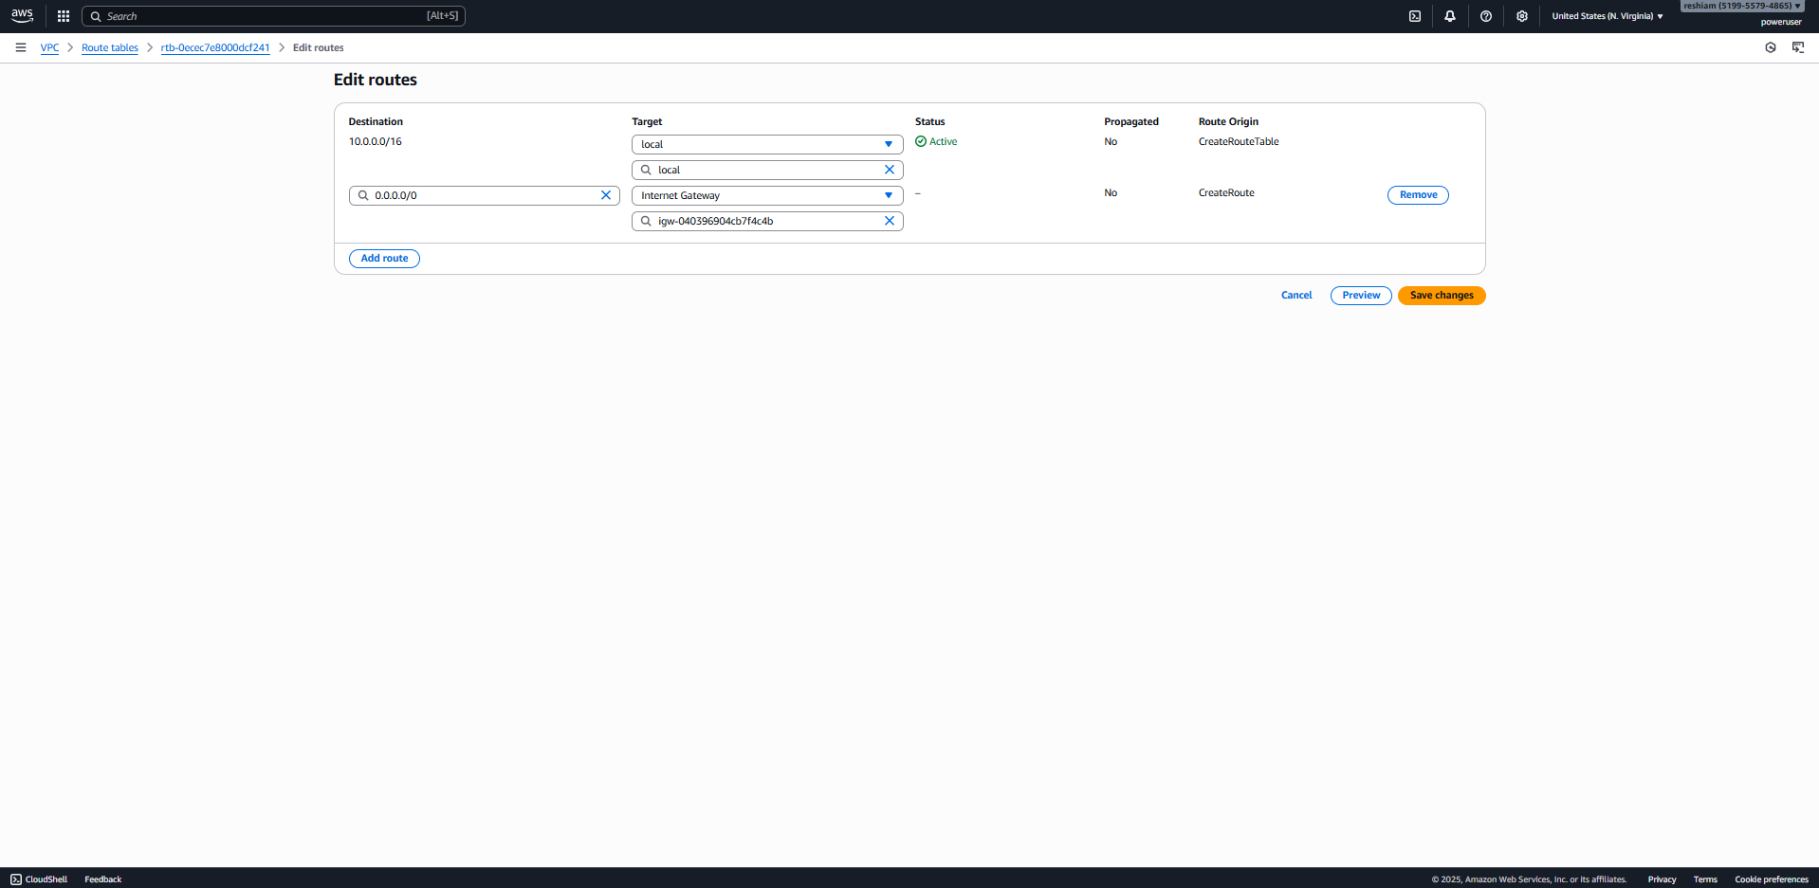
4.Create an IGW

5.Attach IGW to a VPC.
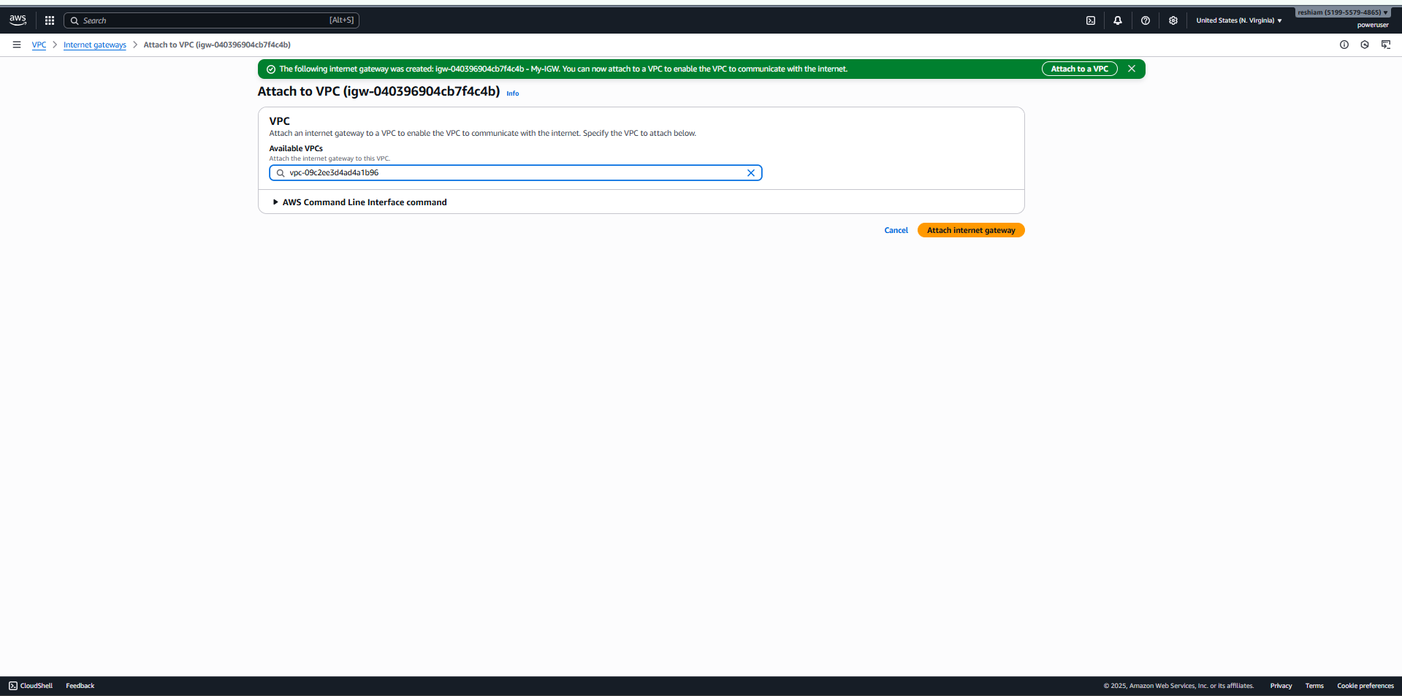
6. Edit subnet associations
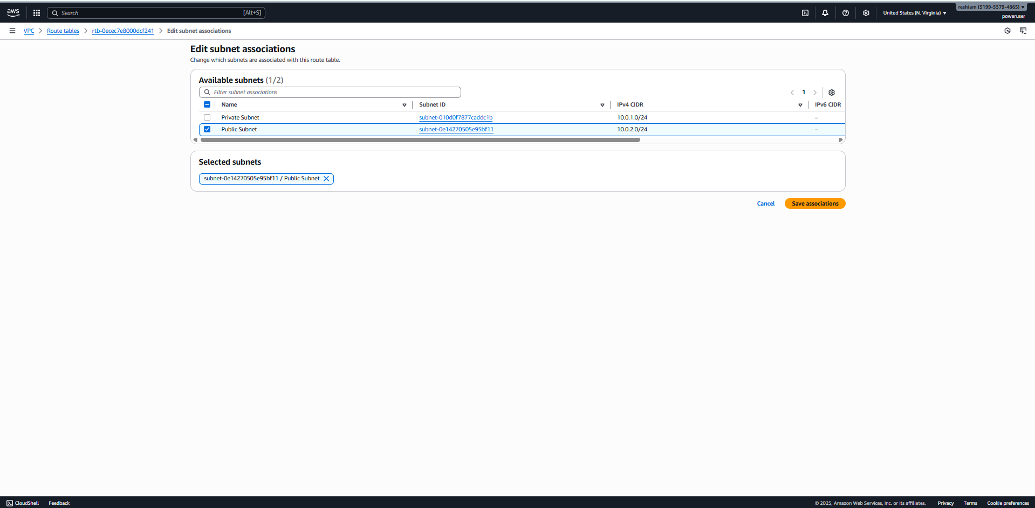
7. Modify Public Subnet to Auto-Assign Public Ips
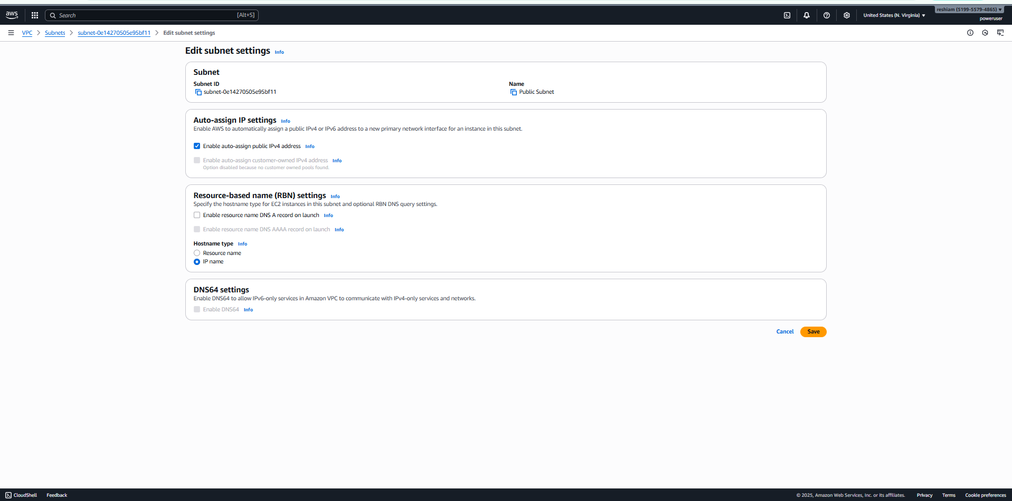
8.Launch an EC2 Linux instance
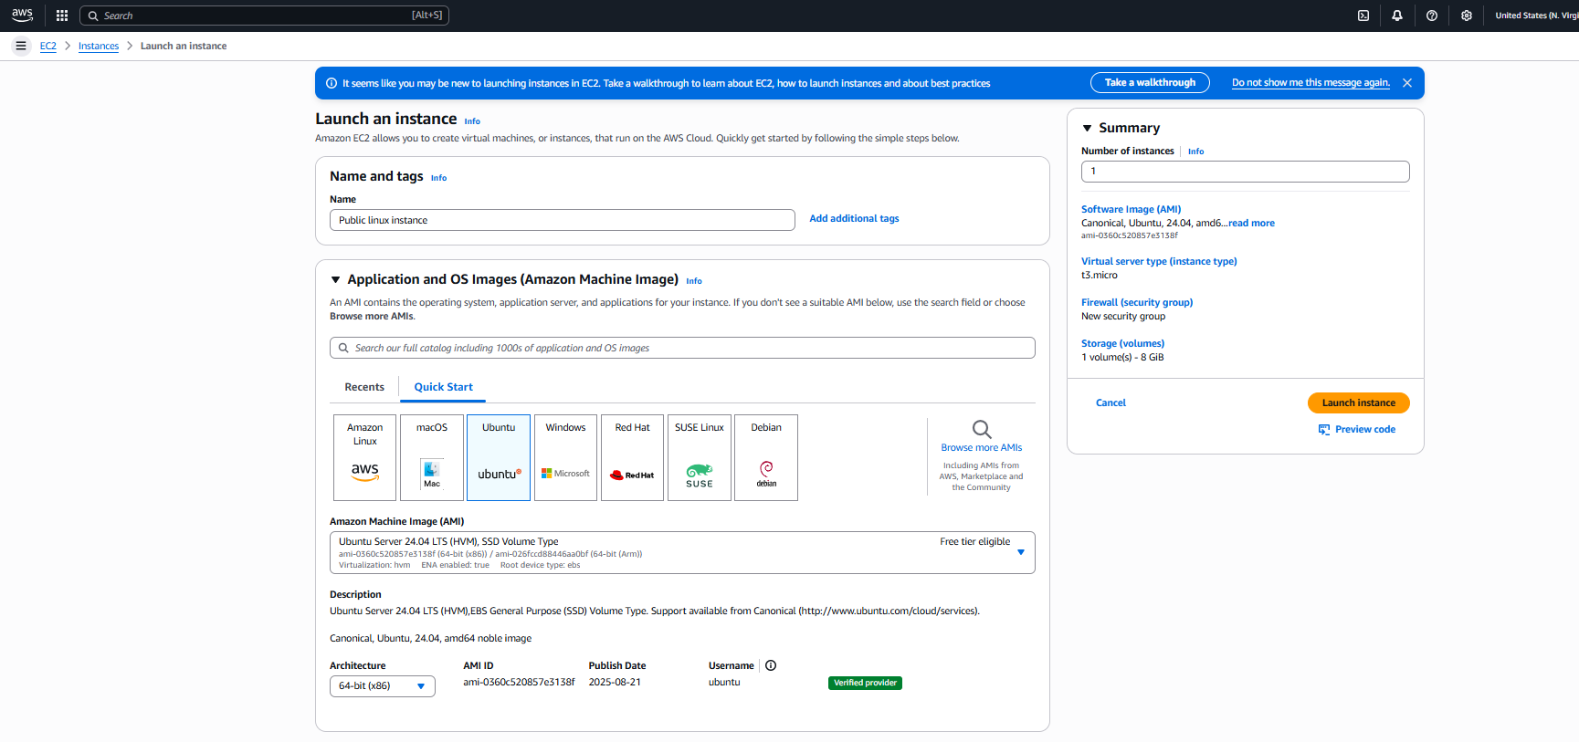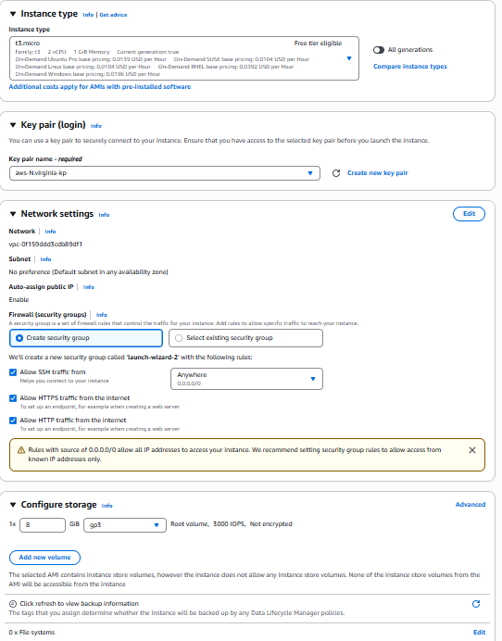
9.Testing using SSH -VPC and Public subnet
a. Take the Public IPV4 address from the instance
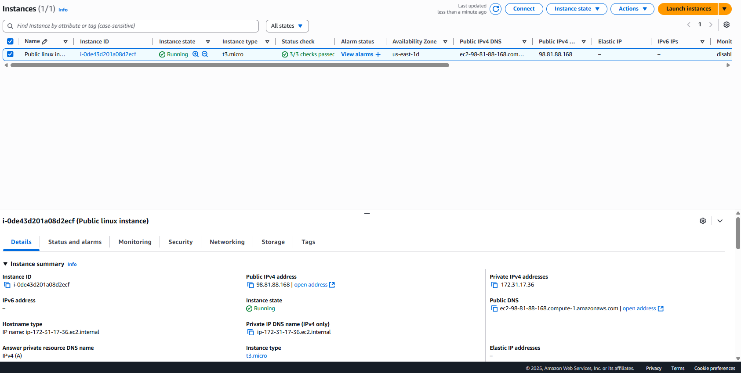
b. Connect to an SSH
